BT3040 • BIOINFORMATICS LABORATORY
Practical 4 — Sequence Alignment
Dot plots, affine gap scoring, Needleman–Wunsch and Smith–Waterman
SUBMITTED BY  Lino Joseph | ROLL NUMBER  BE24B028 | SUBMITTED ON  7 September 2026
Code repository: https://github.com/NightCoderLJ/Bioinformatids_Assignments_be28
Every script quoted in this report is listed there under the folder for this practical, and the tables for the two hand-worked questions are in the accompanying workbook Q3_Q5_manual_tables.xlsx.
1 | Dot plot of human and chicken haemoglobin β chain
(a) Write a program to construct a dot plot for the alignment of human and chicken haemoglobin β chain. Identify the segments which are the same in both sequences.
(b) Construct the dot plot manually for residues 1–20 and verify it against the plot produced by the program.
METHOD
Both chains are 147 residues long, so the dot matrix is a 147 × 147 grid. The script compares every human residue with every chicken residue and marks the cell whenever the two agree. Conserved regions then appear as runs of marks lying along a diagonal.
The identical segments are picked out from the same comparison: wherever a diagonal run of agreements starts, it is followed as far as it goes, and any run of four residues or more is reported.
CODE
The link to the github repository which has the code file is given in the beginning
q1.py
# Q1 - Dot plot for the human and chicken haemoglobin beta chain

import matplotlib.pyplot as plt

human = ("MVHLTPEEKSAVTALWGKVNVDEVGGEALGRLLVVYPWTQRFFESFGDLSTPDAVMGNPKV"
"KAHGKKVLGAFSDGLAHLDNLKGTFATLSELHCDKLHVDPENFRLLGNVLVCVLAHHFGKE"
"FTPPVQAAYQKVVAGVANALAHKYH")

chicken = ("MVHWTAEEKQLITGLWGKVNVAECGAEALARLLIVYPWTQRFFASFGNLSSPTAILGNPMV"
"RAHGKKVLTSFGDAVKNLDNIKNTFSQLSELHCDKLHVDPENFRLLGDILIIVLAAHFSKD"
"FTPECQAAWQKLVRVVAHALARKYH")

def dot_plot(seq1, seq2, filename):
x, y = [], []
for i in range(len(seq1)):
for j in range(len(seq2)):
if seq1[i] == seq2[j]:
x.append(i + 1)
y.append(j + 1)
plt.figure(figsize=(6, 6))
plt.scatter(x, y, s=4, marker="s", color="black")
plt.xlabel("Human HBB")
plt.ylabel("Chicken HBB")
plt.gca().invert_yaxis()
plt.savefig(filename, dpi=200, bbox_inches="tight")
plt.close()

def same_segments(seq1, seq2, min_length=4):
segments = []
for i in range(len(seq1)):
for j in range(len(seq2)):
# only start counting at the beginning of a diagonal run
if seq1[i] != seq2[j]:
continue
if i > 0 and j > 0 and seq1[i - 1] == seq2[j - 1]:
continue
n = 0
while i + n < len(seq1) and j + n < len(seq2) and seq1[i + n] == seq2[j + n]:
n += 1
if n >= min_length:
segments.append((i + 1, j + 1, n, seq1[i:i + n]))
return segments

dot_plot(human, chicken, "q1_dotplot.png")
dot_plot(human[:20], chicken[:20], "q1_dotplot_first20.png")

print("Segments identical in both sequences (length >= 4):")
for start1, start2, n, seq in same_segments(human, chicken):
print(f"human {start1}-{start1 + n - 1} chicken {start2}-{start2 + n - 1} {seq}")
PROGRAM OUTPUT
Segments identical in both sequences (length >= 4):
human 15-21 chicken 15-21 LWGKVNV
human 35-43 chicken 35-43 VYPWTQRFF
human 45-48 chicken 71-74 SFGD
human 63-69 chicken 63-69 AHGKKVL
human 89-108 chicken 89-108 LSELHCDKLHVDPENFRLLG
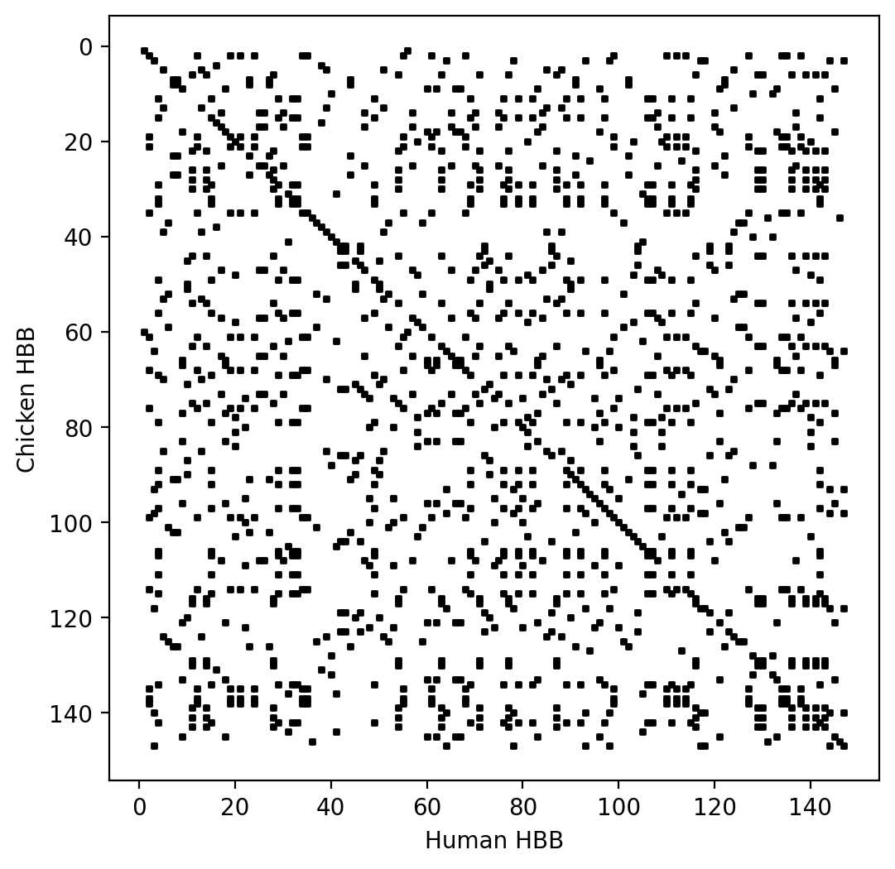
Dot plot of the two chains — the diagonal running corner to corner is the conserved backbone of the fold.
Five stretches of four residues or more are identical in the two chains. The longest, LSELHCDKLHVDPENFRLLG, runs from residue 89 to 108 in both proteins and covers the F helix and the proximal histidine region, which is exactly the part of the fold that grips the haem iron and therefore cannot drift. LWGKVNV (15–21), VYPWTQRFF (35–43) and AHGKKVL (63–69) sit in the same positions in both chains as well. Only SFGD is out of register: residues 45–48 of the human chain match residues 71–74 of the chicken chain, so it sits off the main diagonal in the plot.
PART (B) — THE FIRST TWENTY RESIDUES BY HAND
Human residues 1–20 read MVHLTPEEKSAVTALWGKVN and chicken residues 1–20 read MVHWTAEEKQLITGLWGKVN. Writing the human sequence across the top and the chicken sequence down the side and marking every cell whose two letters agree gives the grid below — thirty-one filled cells, drawn without any help from the program.
 | M | V | H | L | T | P | E | E | K | S | A | V | T | A | L | W | G | K | V | N
M | ●
V |  | ● |  |  |  |  |  |  |  |  |  | ● |  |  |  |  |  |  | ●
H |  |  | ●
W |  |  |  |  |  |  |  |  |  |  |  |  |  |  |  | ●
T |  |  |  |  | ● |  |  |  |  |  |  |  | ●
A |  |  |  |  |  |  |  |  |  |  | ● |  |  | ●
E |  |  |  |  |  |  | ● | ●
E |  |  |  |  |  |  | ● | ●
K |  |  |  |  |  |  |  |  | ● |  |  |  |  |  |  |  |  | ●
Q
L |  |  |  | ● |  |  |  |  |  |  |  |  |  |  | ●
I
T |  |  |  |  | ● |  |  |  |  |  |  |  | ●
G |  |  |  |  |  |  |  |  |  |  |  |  |  |  |  |  | ●
L |  |  |  | ● |  |  |  |  |  |  |  |  |  |  | ●
W |  |  |  |  |  |  |  |  |  |  |  |  |  |  |  | ●
G |  |  |  |  |  |  |  |  |  |  |  |  |  |  |  |  | ●
K |  |  |  |  |  |  |  |  | ● |  |  |  |  |  |  |  |  | ●
V |  | ● |  |  |  |  |  |  |  |  |  | ● |  |  |  |  |  |  | ●
N |  |  |  |  |  |  |  |  |  |  |  |  |  |  |  |  |  |  |  | ●
Running q1.py on the same two twenty-residue fragments gives the plot below. Every marked point corresponds to a filled cell in the table above — (1, 1) for the two methionines, the 2 × 2 block where the glutamates at positions 7 and 8 of both fragments meet, and the short unbroken diagonal from (15, 15) to (19, 19) for LWGKV — so the hand-drawn grid and the program agree.
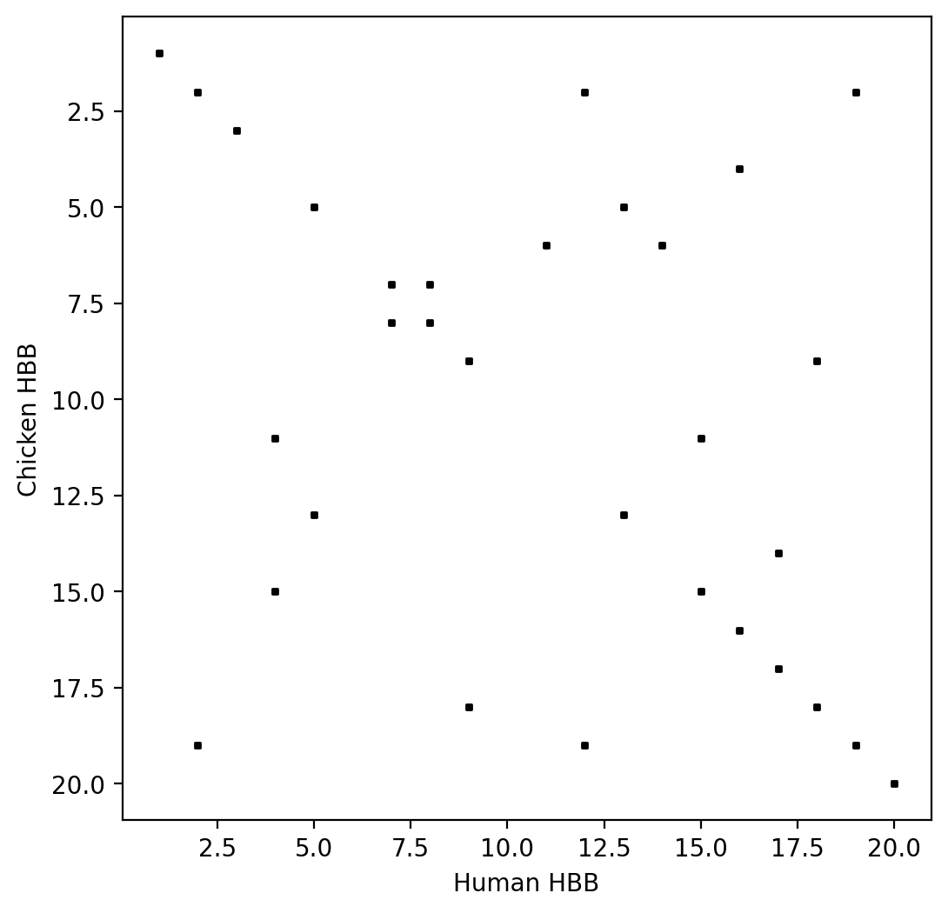
The same twenty residues plotted by the program.

2 | Scoring an alignment with affine gap penalties
Calculate the score for the alignment AATCTATA over AAG--ATA using code.
Match +1, mismatch 0, origination penalty −2, length penalty −1.
METHOD
The two rows are read one column at a time. A column with a dash in either row belongs to a gap; the length penalty is charged on every such column and the origination penalty only on the first, so the script keeps a flag saying whether the previous column was already inside a gap. Any column without a dash clears the flag and scores +1 or 0 depending on whether the two residues agree.
CODE
q2.py
# Q2 - Score of the alignment AATCTATA / AAG--ATA

seq1 = "AATCTATA"
seq2 = "AAG--ATA"

match = 1
mismatch = 0
origination = -2
length = -1

score = 0
in_gap = False

for a, b in zip(seq1, seq2):
if a == "-" or b == "-":
if not in_gap: # first column of a new gap
score += origination
in_gap = True
score += length
else:
in_gap = False
score += match if a == b else mismatch

print(seq1)
print(seq2)
print("Alignment score:", score)
PROGRAM OUTPUT
AATCTATA
AAG--ATA
Alignment score: 1
The alignment scores 1: five matches worth +1 each, one mismatch worth 0, and a two-column gap costing −4 in total, since the origination penalty is charged once and the length penalty twice. The column-by-column working is set out in Q3.

3 | Hand verification of the Q2 score
Verify Q2 manually.
The check was laid out in Excel rather than on paper, in the sheet Q3 manual score of the workbook Q3_Q5_manual_tables.xlsx. Each of the eight columns of the alignment gets one row, and the origination, length and match contributions are separate columns so the affine cost is visible rather than assumed. The scoring parameters sit in their own cells and every entry in the table is a formula pointing at them, so changing a penalty updates the whole sheet.
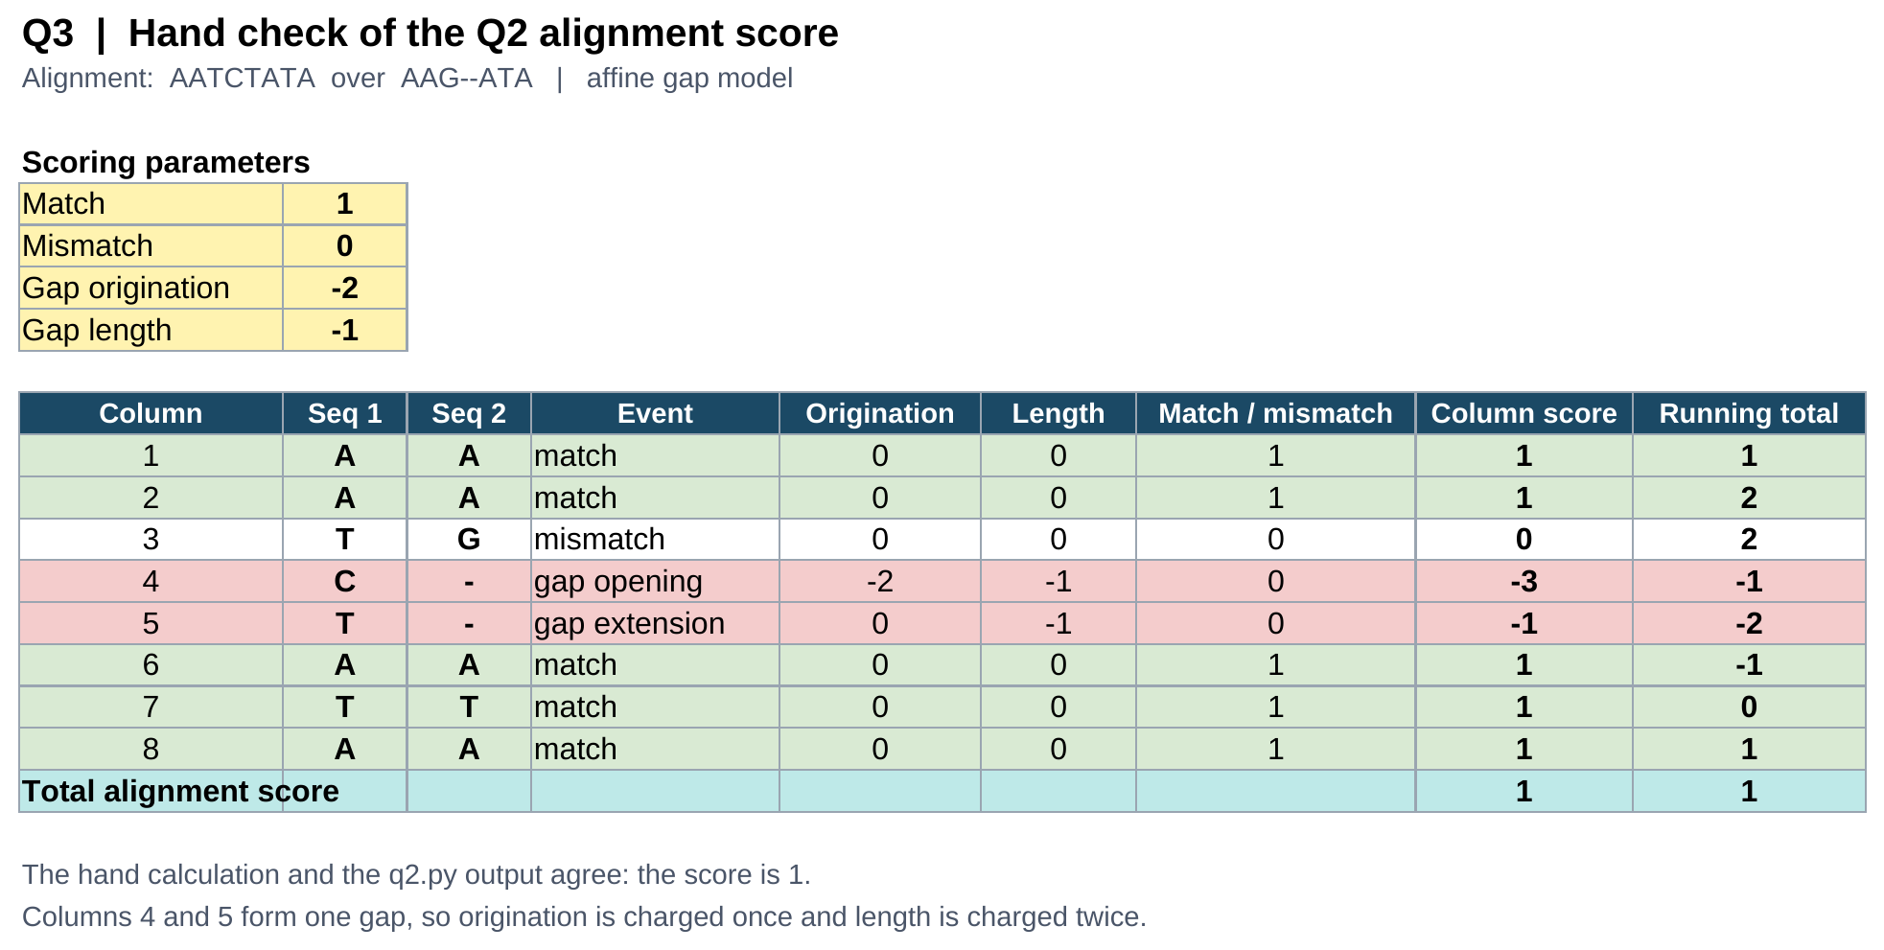
Sheet “Q3 manual score” of Q3_Q5_manual_tables.xlsx
Adding the column scores gives 1 + 1 + 0 − 3 − 1 + 1 + 1 + 1 = 1, which is what q2.py printed. The running total column shows the score dipping to −2 in the middle of the gap before the three trailing matches pull it back up.

4 | Global alignment by Needleman–Wunsch
Using the Needleman and Wunsch dynamic programming method, construct the partial alignment score table and align ACAGTCGAACG and ACCGTCCG using code.
Match +2, mismatch −1, gap penalty −2.
METHOD
A score table of 12 rows by 9 columns is built, one extra row and column for the empty prefix. The first row and column are filled with multiples of the gap penalty, since aligning a prefix against nothing can only be done with gaps. Every other cell takes the best of three choices: come from the diagonal and pair the two residues, come from above and put a gap in the second sequence, or come from the left and put a gap in the first. Starting at the bottom right corner and checking which of the three produced the value in each cell traces the path back to the origin and spells out the alignment.
CODE
The link to the github repository which has the code file is given in the beginning
q4.py
# Q4 - Global alignment of ACAGTCGAACG and ACCGTCCG (Needleman-Wunsch)

seq1 = "ACAGTCGAACG"
seq2 = "ACCGTCCG"

match = 2
mismatch = -1
gap = -2

n, m = len(seq1), len(seq2)

# build the score table
table = [[0] * (m + 1) for _ in range(n + 1)]
for i in range(1, n + 1):
table[i][0] = i * gap
for j in range(1, m + 1):
table[0][j] = j * gap

for i in range(1, n + 1):
for j in range(1, m + 1):
pair = match if seq1[i - 1] == seq2[j - 1] else mismatch
table[i][j] = max(table[i - 1][j - 1] + pair,
table[i - 1][j] + gap,
table[i][j - 1] + gap)

print("Partial alignment score table")
print(" " + "".join(f"{c:>5}" for c in "-" + seq2))
for i in range(n + 1):
label = "-" if i == 0 else seq1[i - 1]
print(f"{label:>5}" + "".join(f"{v:>5}" for v in table[i]))

# traceback from the bottom right corner
align1, align2 = "", ""
i, j = n, m
while i > 0 or j > 0:
pair = match if (i and j and seq1[i - 1] == seq2[j - 1]) else mismatch
if i and j and table[i][j] == table[i - 1][j - 1] + pair:
align1, align2 = seq1[i - 1] + align1, seq2[j - 1] + align2
i, j = i - 1, j - 1
elif i and table[i][j] == table[i - 1][j] + gap:
align1, align2 = seq1[i - 1] + align1, "-" + align2
i -= 1
else:
align1, align2 = "-" + align1, seq2[j - 1] + align2
j -= 1

print("\nOptimal alignment")
print(align1)
print(align2)
print("Alignment score:", table[n][m])
PROGRAM OUTPUT
Partial alignment score table
- A C C G T C C G
- 0 -2 -4 -6 -8 -10 -12 -14 -16
A -2 2 0 -2 -4 -6 -8 -10 -12
C -4 0 4 2 0 -2 -4 -6 -8
A -6 -2 2 3 1 -1 -3 -5 -7
G -8 -4 0 1 5 3 1 -1 -3
T -10 -6 -2 -1 3 7 5 3 1
C -12 -8 -4 0 1 5 9 7 5
G -14 -10 -6 -2 2 3 7 8 9
A -16 -12 -8 -4 0 1 5 6 7
A -18 -14 -10 -6 -2 -1 3 4 5
C -20 -16 -12 -8 -4 -3 1 5 3
G -22 -18 -14 -10 -6 -5 -1 3 7

Optimal alignment
ACAGTCGAACG
ACCGTC---CG
Alignment score: 7
The optimal global alignment scores 7. Seven of the eleven columns are matches worth +2 each, column three is an A against C mismatch worth −1, and the run GAA in the first sequence has no counterpart in the second, so it is absorbed by a three-residue gap costing −6. That gives 14 − 1 − 6 = 7, the value sitting in the bottom right cell of the table.

5 | Hand verification of the Needleman–Wunsch table
Verify Q4 manually.
The matrix was rebuilt in Excel, in the sheet Q5 manual NW table of Q3_Q5_manual_tables.xlsx. Only the top left zero is typed in; every other cell carries the recurrence itself, MAX(diagonal + match or mismatch, cell above + gap, cell to the left + gap), written against the parameter cells. The sheet therefore derives the table instead of copying the numbers the program printed. The shaded cells are the traceback path.
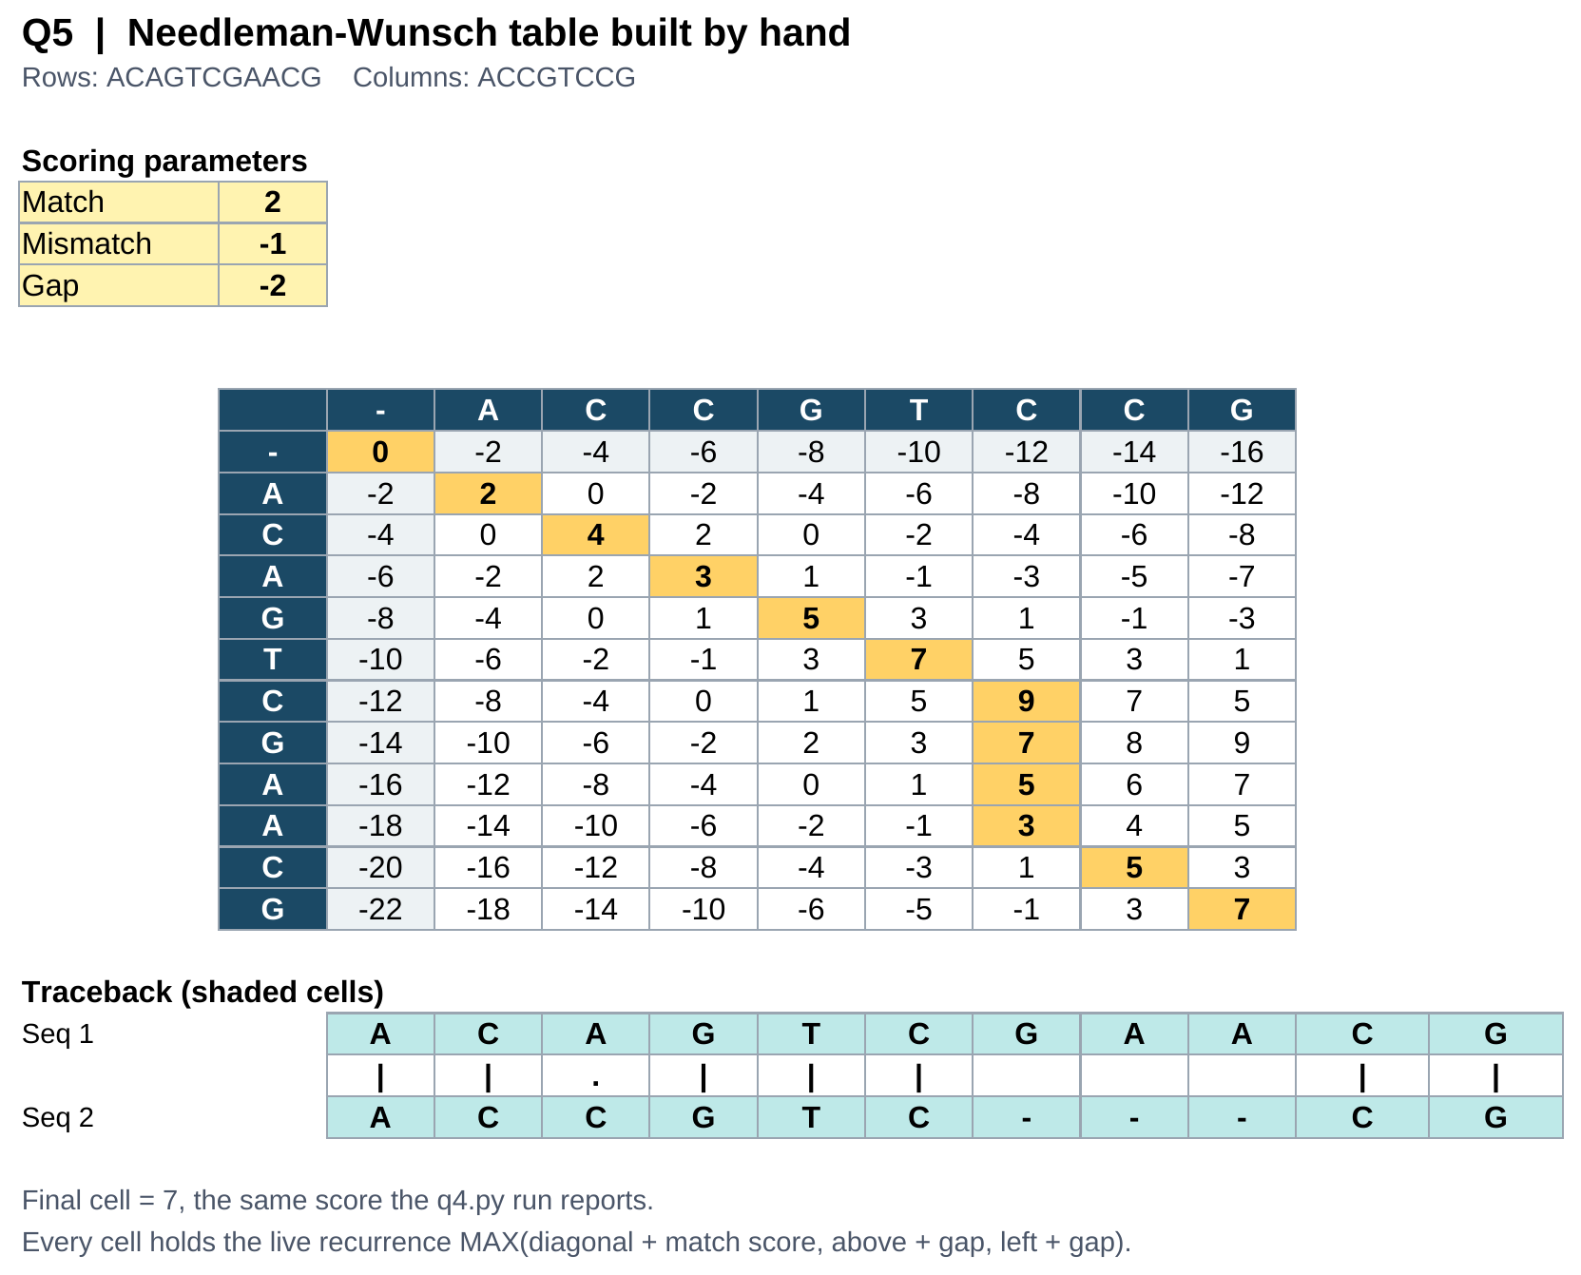
Sheet “Q5 manual NW table” of Q3_Q5_manual_tables.xlsx
The bottom right cell holds 7 and the shaded path reads 0, 2, 4, 3, 5, 7, 9, 8, 6, 4, 5, 7. Six diagonal steps give the leading ACAGTC against ACCGTC, three vertical steps insert the gap opposite GAA, and two more diagonal steps finish on CG. Both the matrix and the alignment agree with q4.py.

6 | Local alignment by Smith–Waterman
Using the Smith–Waterman method, construct the partial alignment scoring table and align ACGTATCGCGTATA and GATGCGTATCG using code.
Match +2, mismatch −1, gap penalty −2.
METHOD
Smith–Waterman uses the same three-way recurrence as Needleman–Wunsch with two changes. The first row and column stay at zero, and any cell whose best option would be negative is reset to zero, which lets a fresh alignment start anywhere in the table instead of being dragged down by a poor prefix. The traceback then starts at the highest cell in the whole table rather than at the corner, and stops at the first zero it meets.
CODE
The link to the github repository which has the code file is given in the beginning
q6.py
# Q6 - Local alignment of ACGTATCGCGTATA and GATGCGTATCG (Smith-Waterman)

seq1 = "ACGTATCGCGTATA"
seq2 = "GATGCGTATCG"

match = 2
mismatch = -1
gap = -2

n, m = len(seq1), len(seq2)

# build the score table; negative scores are reset to zero
table = [[0] * (m + 1) for _ in range(n + 1)]
best, best_i, best_j = 0, 0, 0

for i in range(1, n + 1):
for j in range(1, m + 1):
pair = match if seq1[i - 1] == seq2[j - 1] else mismatch
table[i][j] = max(0,
table[i - 1][j - 1] + pair,
table[i - 1][j] + gap,
table[i][j - 1] + gap)
if table[i][j] > best:
best, best_i, best_j = table[i][j], i, j

print("Partial alignment score table")
print(" " + "".join(f"{c:>4}" for c in "-" + seq2))
for i in range(n + 1):
label = "-" if i == 0 else seq1[i - 1]
print(f"{label:>4}" + "".join(f"{v:>4}" for v in table[i]))

# traceback from the highest cell until a zero is reached
align1, align2 = "", ""
i, j = best_i, best_j
while i > 0 and j > 0 and table[i][j] > 0:
pair = match if seq1[i - 1] == seq2[j - 1] else mismatch
if table[i][j] == table[i - 1][j - 1] + pair:
align1, align2 = seq1[i - 1] + align1, seq2[j - 1] + align2
i, j = i - 1, j - 1
elif table[i][j] == table[i - 1][j] + gap:
align1, align2 = seq1[i - 1] + align1, "-" + align2
i -= 1
else:
align1, align2 = "-" + align1, seq2[j - 1] + align2
j -= 1

print("\nBest local alignment")
print(align1)
print(align2)
print(f"Position: seq1 {i + 1}-{best_i}, seq2 {j + 1}-{best_j}")
print("Alignment score:", best)
PROGRAM OUTPUT
Partial alignment score table
- G A T G C G T A T C G
- 0 0 0 0 0 0 0 0 0 0 0 0
A 0 0 2 0 0 0 0 0 2 0 0 0
C 0 0 0 1 0 2 0 0 0 1 2 0
G 0 2 0 0 3 1 4 2 0 0 0 4
T 0 0 1 2 1 2 2 6 4 2 0 2
A 0 0 2 0 1 0 1 4 8 6 4 2
T 0 0 0 4 2 0 0 3 6 10 8 6
C 0 0 0 2 3 4 2 1 4 8 12 10
G 0 2 0 0 4 2 6 4 2 6 10 14
C 0 0 1 0 2 6 4 5 3 4 8 12
G 0 2 0 0 2 4 8 6 4 2 6 10
T 0 0 1 2 0 2 6 10 8 6 4 8
A 0 0 2 0 1 0 4 8 12 10 8 6
T 0 0 0 4 2 0 2 6 10 14 12 10
A 0 0 2 2 3 1 0 4 8 12 13 11

Best local alignment
CGTATCG
CGTATCG
Position: seq1 2-8, seq2 5-11
Alignment score: 14
The highest cell in the table holds 14, and tracing back from it gives CGTATCG against CGTATCG — seven consecutive matches worth 2 each, with no gaps and no mismatches. The segment sits at positions 2–8 of ACGTATCGCGTATA and 5–11 of GATGCGTATCG. A global method would have been forced to align the flanking residues as well and would have reported a much poorer score for what is really a clean shared motif.

∑ | Results at a glance

Q | What was asked | Result obtained
1 | Dot plot, human vs chicken β chain | 5 identical segments
2 | Affine gap score, AATCTATA / AAG--ATA | score = 1
3 | Same score worked by hand in Excel | score = 1
4 | Needleman–Wunsch, global alignment | score = 7
5 | Same matrix rebuilt by hand in Excel | score = 7
6 | Smith–Waterman, local alignment | score = 14, CGTATCG
Files submitted with this report: q1.py, q2.py, q4.py, q6.py and Q3_Q5_manual_tables.xlsx.

